BLOCK GUIDE

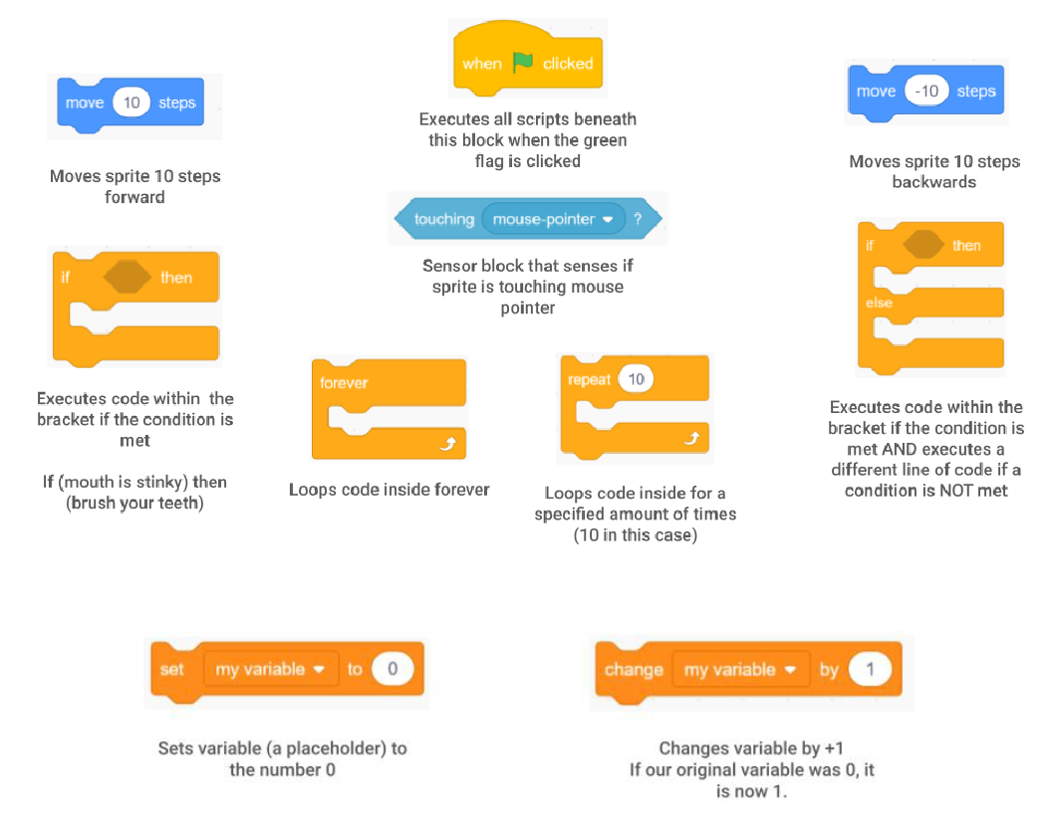

**Making Interactive Sprites**

**Task #0: Open a new Scratch workspace**

1. Go to the Scratch website. Click on Create.

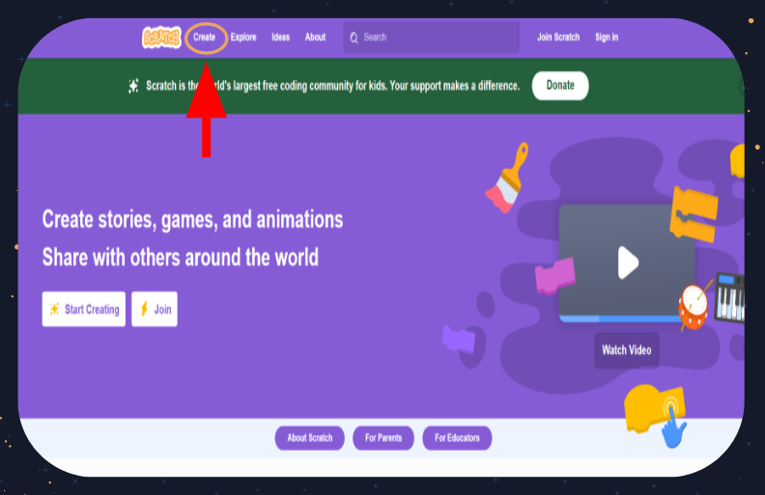

1. A new Scratch workspace should appear like this.

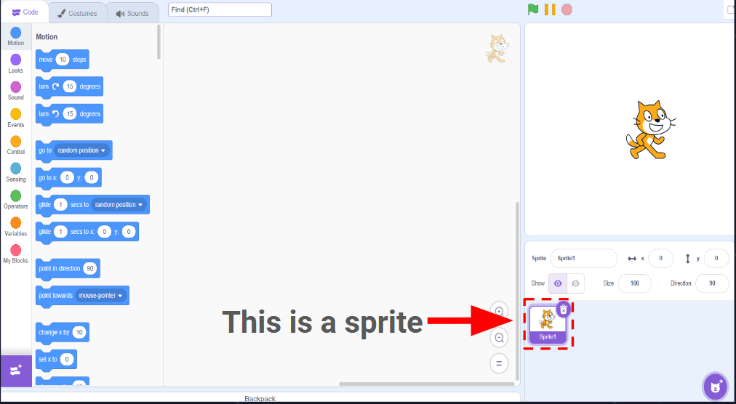

**Task #1: Character movement by interacting with the sprites (Optional)**

Our goal for this portion of the workshop is to code a sprite that moves backwards when your mouse is not touching it and move forward when your mouse is.

**Step 1**: Pull out a ‘when green flag clicked’ from the control category

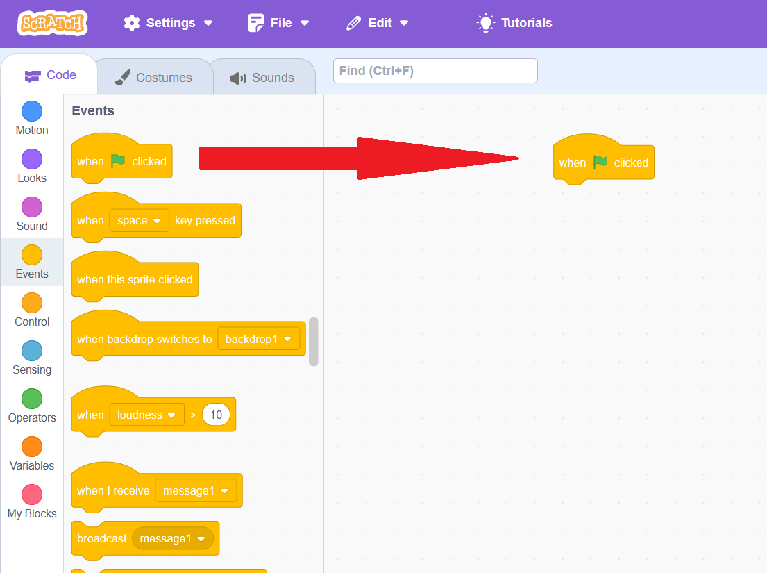

**Step 2**: pull out a move 10 motion block and place it underneath the ‘when green flag clicked’ block to connect it.

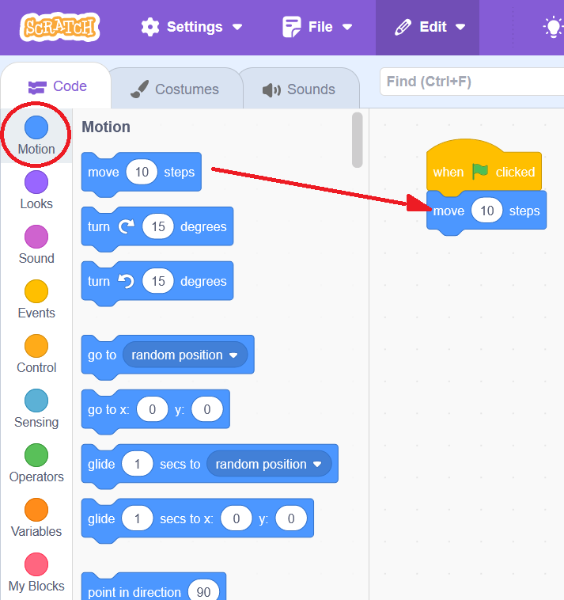

When the green flag above the viewport is pressed, Scratchy the Cat moves 10 steps forward.

**Step 3**: Press the stop sign. edit the number within the move block so it says ‘-10’ instead of ‘10’. Press the green flag and observe.

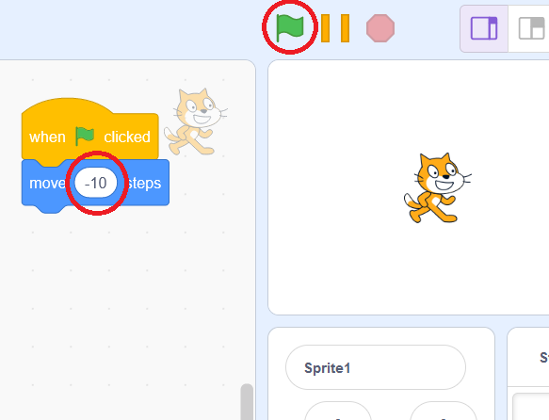

Scratchy should move 10 steps backwards.

**Step 4**: Pull out a forever block from the control category

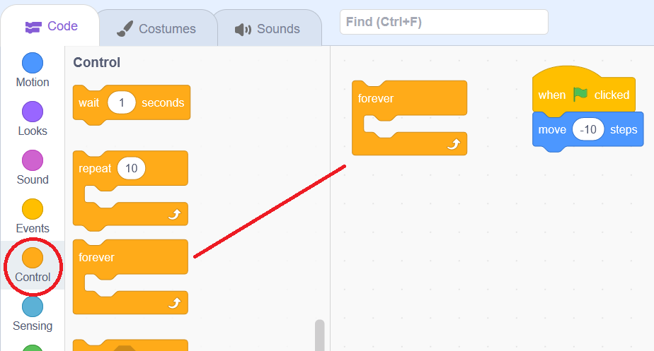

**Step 5**: place the move ‘10’ or ‘-10’ block inside of the forever block

**Step 6**: press the green flag and observe.

Scratchy moves infinitely until he reaches the end of our viewport.

**Step 7**: Press the stop sign and click and drag Scratchy back to the center of the screen.

**Step 8**: Pull out an ‘if-then block’ from the Control category and the ‘touching’ block from the sensing category. The ‘touching’ block should be set to mouse-pointer by default.

**Step 9**: drag the sensing block into the space after ‘if’ and drag the ‘move’ block into the space beneath. Make sure its set to ‘10’ and not ‘-10’

Now press the green flag. Scratchy should move forward when your mouse pointer touches him and do nothing when your mouse pointer isn’t touching him.

We want Scratchy to move forward when we place our cursor over him and move backwards when our cursor isn't touching him. To do this, we’re going to use the if else block.

**Step 10**: drag out an ‘if –else’ block from the control category

**Step 11**: drag the blocks from your ‘if-then' into the first space of your new ‘if-else’ block

**Step 12**: Recall what the ‘move -10’ block does. Drag a new move block into the blank ‘else’ section of this block and change the number to ‘-10’

**Step 13**: Make sure your new block is connected to the ‘when green flag clicked’ block and click the green flag!

**Task #2: Character movement by manipulating variables (the Workshop video goes over this)**

Objective: We’re going to make an interactive story where Scratchy the Cat says, “It’s a beautiful day outside!” when the temperature outside is higher than 70 degrees; and says, “Brr it’s cold!” if the temperature is lower than 70 degrees.

**Step 1:** Create a variable called “Temperature” (Go to the Variables category ~> Click Make a variable). Set the variable Temperature to 75 place it underneath the when green flag clicked.

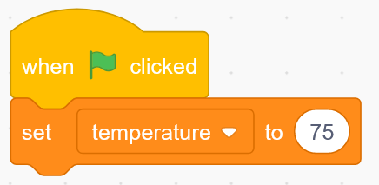

**Step 2:** Pull out two If-then block (Control category), a < block (Operators category), and a > block (Operators category).

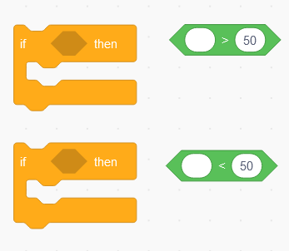

**Step 3:** Place the Operator blocks inside of the If-then blocks and change the numbers from 50 (default value) to 70.

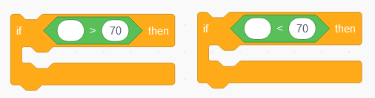

**Step 4:** Pull out a Move block (Movement category) and a Say block (Looks category). Change the value inside the Move block to 200 and inside the Say block to “It’s a beautiful day outside!”. Add a Wait block (Control category).

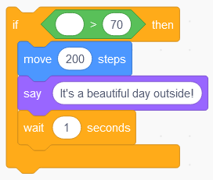

**Step 5:** Now we’re going to program Scratchy the Cat to say something different when the temperature is less than 70. Pull out a Move block and change the number to -50. Pull out a Say block and change it to say “Brr it’s cold outside!” This time, add the wait block to the top.

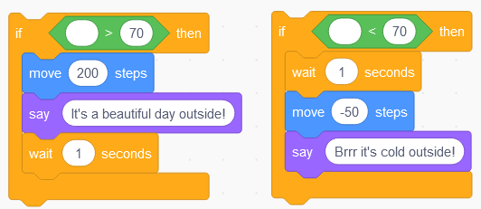

**Step 6:** Go to the Variable category and drag ‘Temperature’ into the blank spot in our operator blocks.

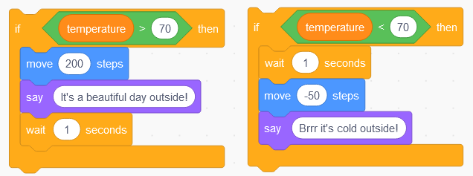

**Step 7:** Now we’re going to connect these all to the When the green flag clicked block.

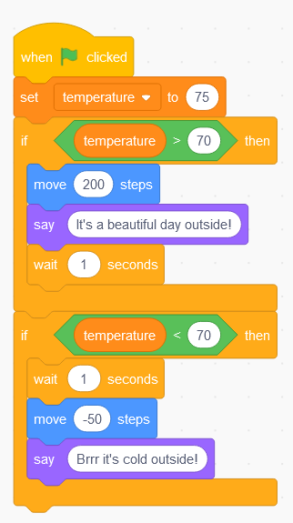

Notice that in the exercise above, we used two if statements. Now, we’re going to learn how to use an if-else statement.

You can first hide our current sprite by clicking on the eyeball icon with a slash. Create a new sprite. You will see a blank workspace appear. After that, you can go ahead and change the backdrop to “Blue Sky”. This is a stock backdrop available in Scratch.

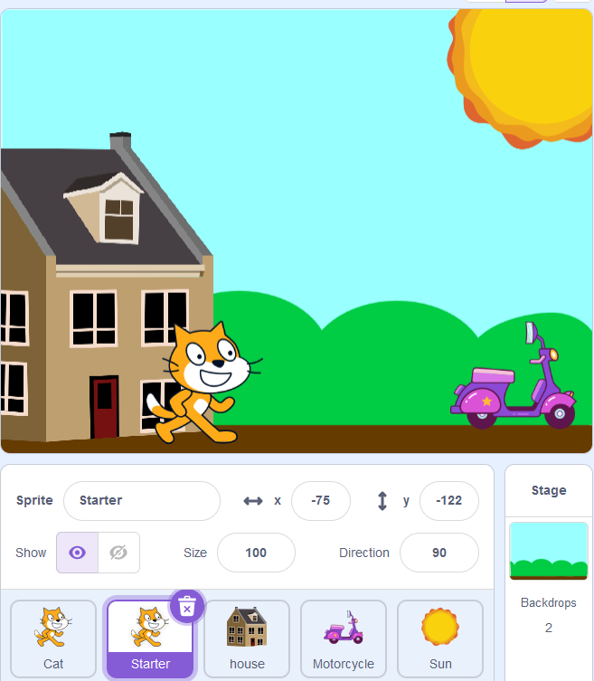

**Step 1:** In the blank workspace, set up a new block of codes like this.

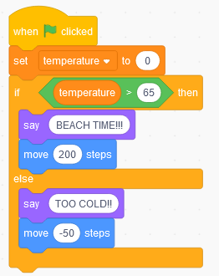

**Step 2:** Change the temperature to 70 degrees then click the green flag and observe what happens.

Right now, we have an if-else statement. Our program will check the condition of the if statement. If the condition is true, the program will execute the codes inside the if block. If the condition is false, the program will jump to the else block.

What if the else block also has its own condition that the program needs to check, just like with the if block? And what if both statements are true?

Let's put an If-then block inside of the else bracket and see what happens.

**Step 3:** Set up an if block and drag it into the else bracket like this. Change the temperature to over 150. Press the green flag and observe what happens.

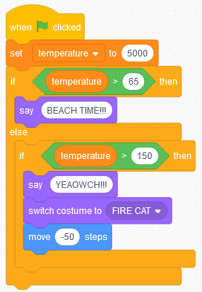

You may have noticed that even though it’s way too hot for this little cat to be outside, he just says beach time. This is because with an if-else statement, only one statement can be true.

In this example, even though the current temperature satisfies the conditions of both the if component and the else component (both are true), the computer checks the first statement first (computer reads from top-down) and finds it to be true. Therefore, it only executes what’s inside the if component and skips the rest of the code.

**Step 4:** Let’s rearrange the codes one last time.

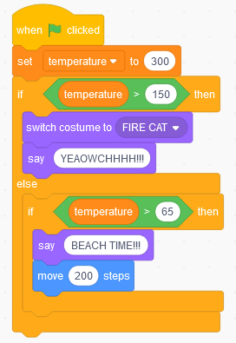

**Task #3: Sprite animation**

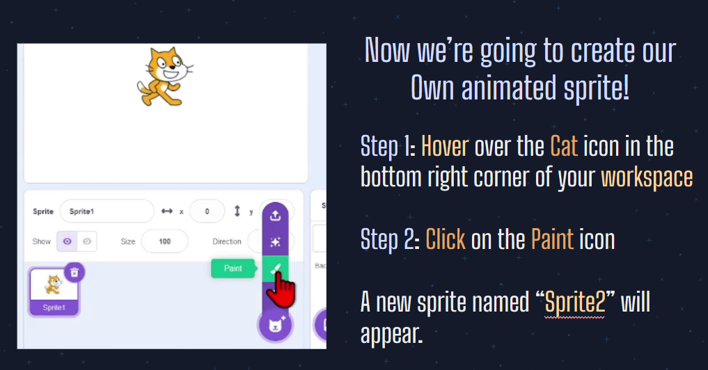

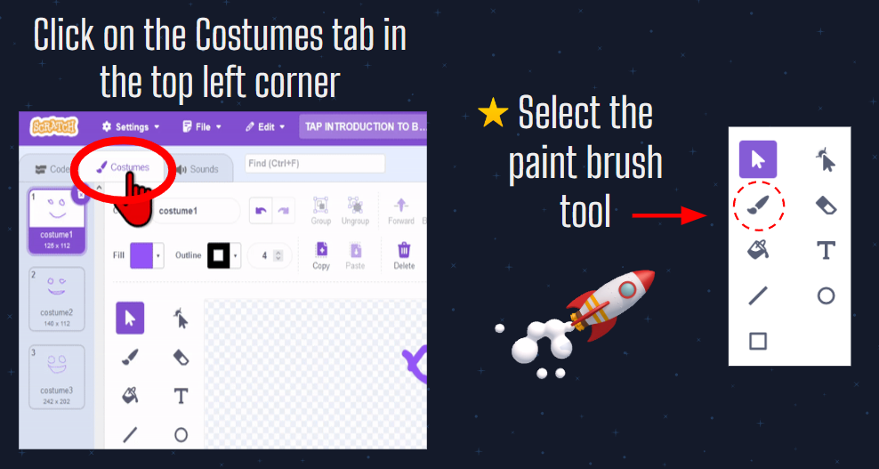

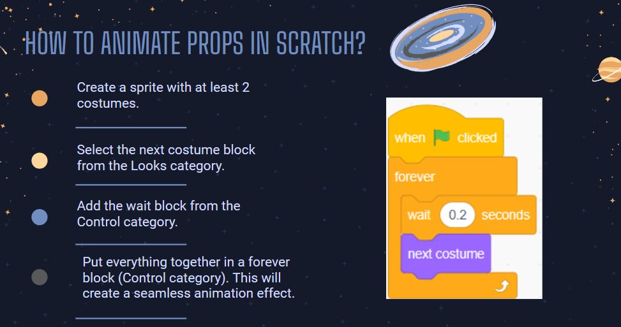

## Playing the Game

1. **How to get to the game:**

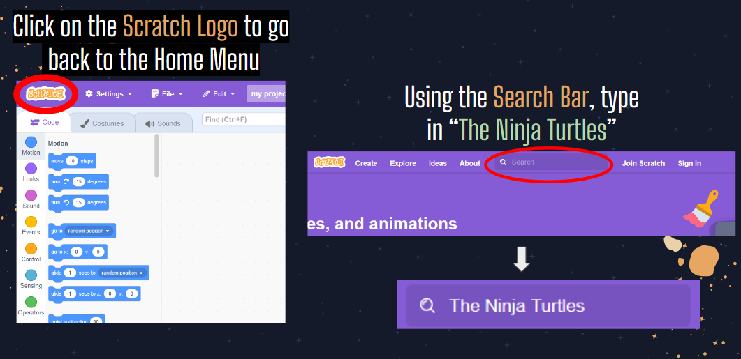

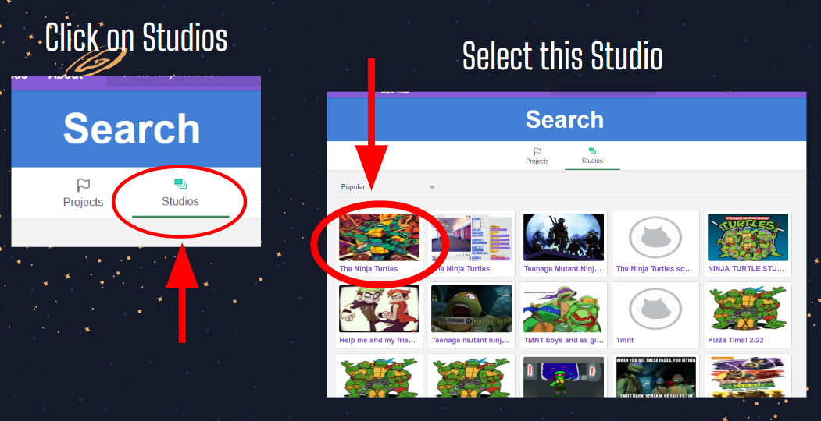

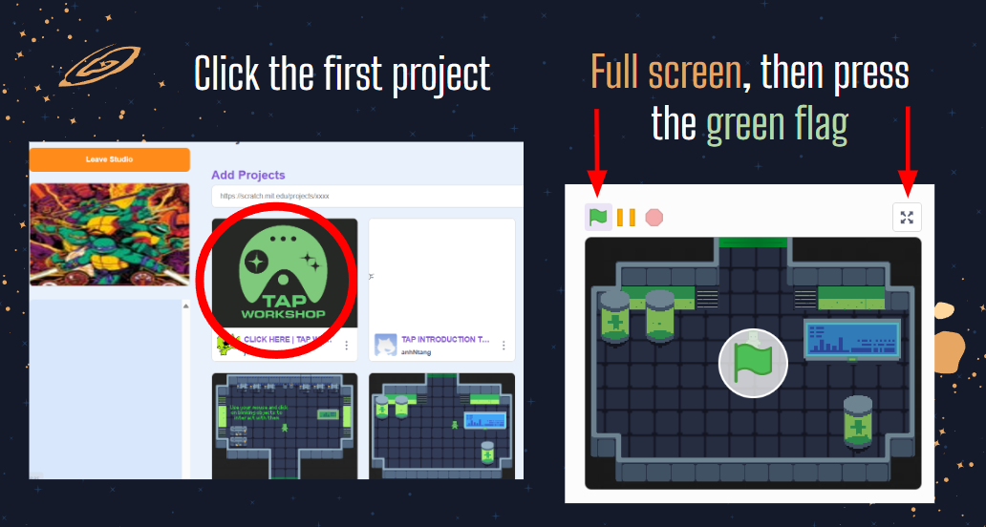

1. **Makey Makey:**

Description: Instead of the keyboard, you will be using the Makey Makey to control the character movement. We have set up multiple Makey Makeys in this room for you to use. Please partner with your neighbors if your computer does not have a Makey Makey set up.

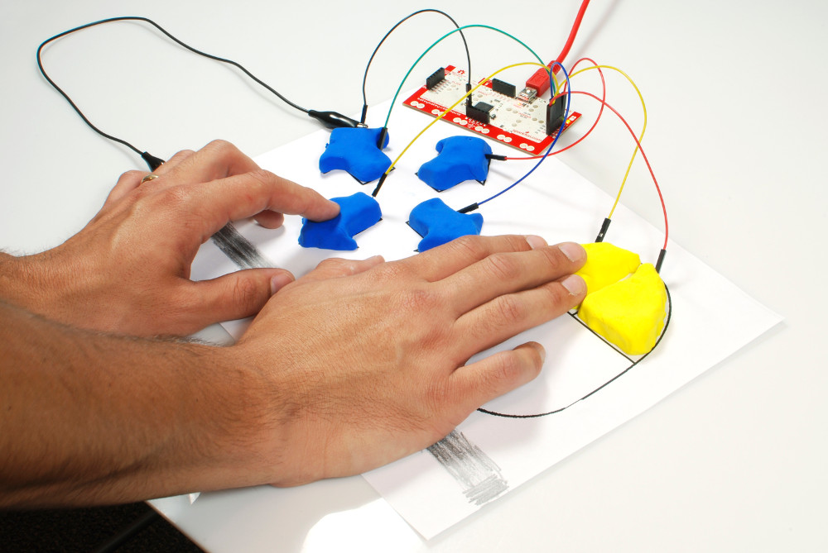

How-to-use:

* The four pieces of Play-Doh on the left represent the 4 arrow keys.
* The piece on the right is referred to as the ground. One of your hands must touch this piece all the time, while the other touches one of the 4 pieces to move the characteraround.

Click this link to learn more about the Makey Makey: [MaKey MaKey Quickstart Guide - SparkFun Learn](https://learn.sparkfun.com/tutorials/makey-makey-quickstart-guide)

1. ****Task description:****

You will be given 10 minutes to solve the programming questions in the first room.

1. Click on the blinking objects. There are 4 objects that you can interact with in this room.
2. Every time you click on an object, a programming question will pop up.
3. Try to get all 4 of them correctly before you move on.
4. Raise your hand if you have any questions.
5. Once you’re done, you can move on to the bonus tasks.

## Bonus Tasks

**First bonus task: Prop animation**

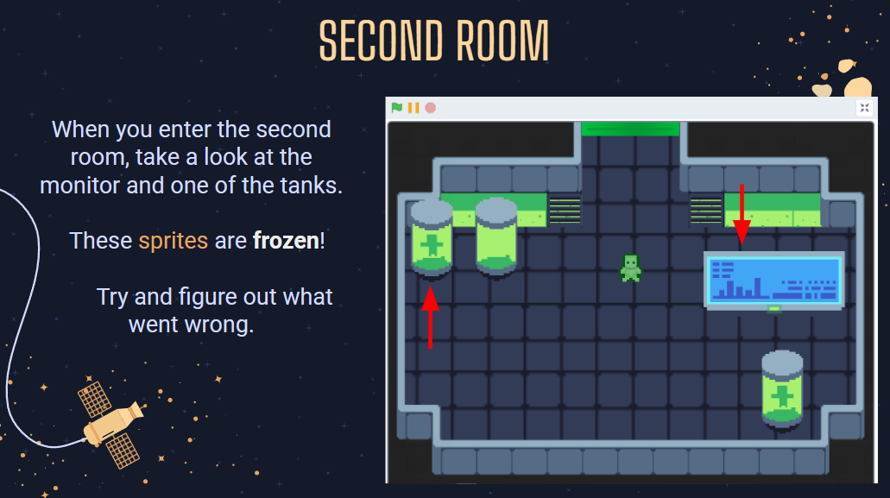

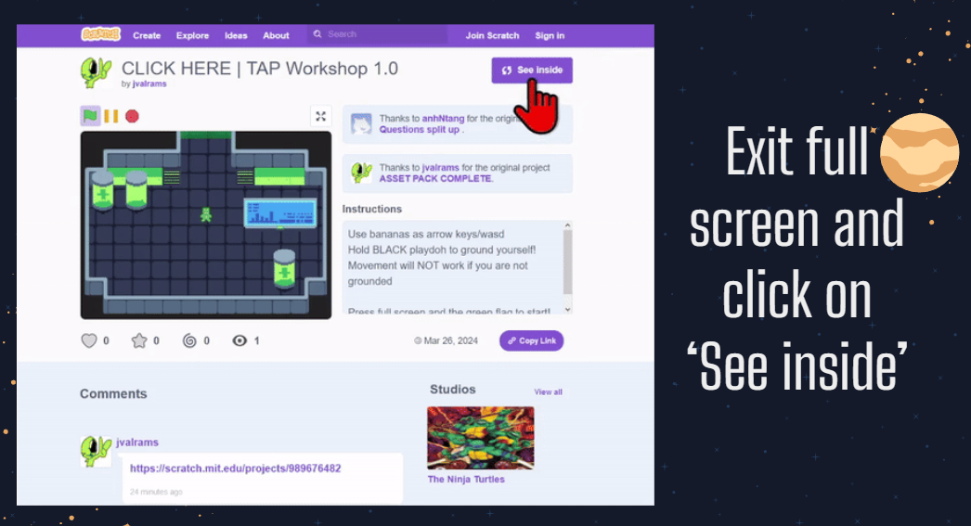

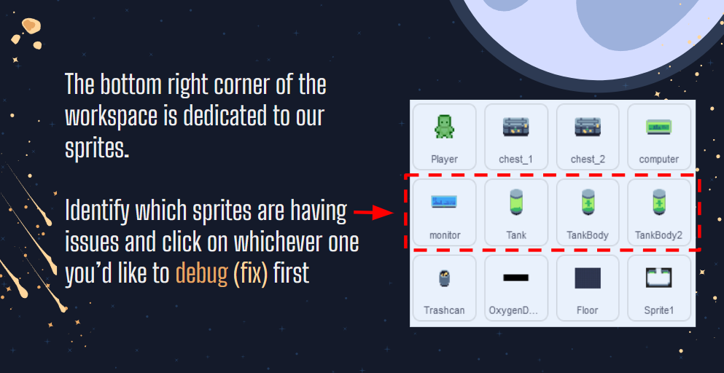

**Second bonus task: Character vertical movement and Collision model**

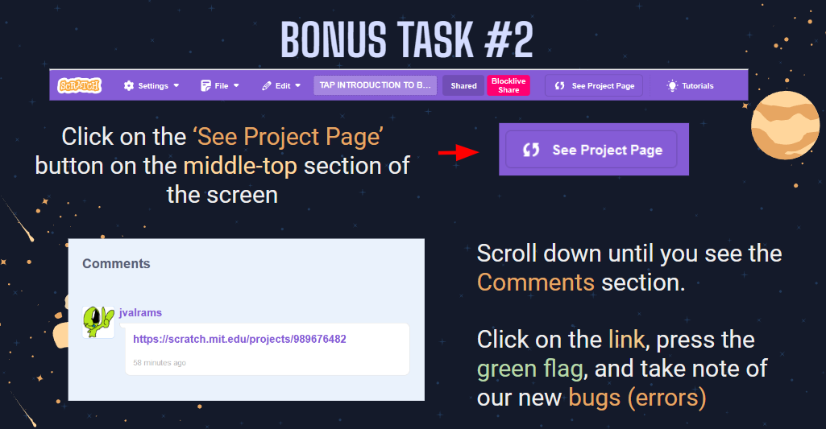

Hints:

* The character seems to be unable to move up and down...
* The character seems to be able to defy the laws of physics and go through objects like a ghost?!